XPATH

Its tells about the xml path is available or not.

Given xml in http request [w3schools.com/xml/note.xml](https://www.w3schools.com/xml/note.xml) i.e,

<note>

<to>Tove</to>

<from>Jani</from>

<heading>Reminder</heading>

<body>Don't forget me this weekend!</body>

</note>

Now validating the xpath

* Adding assertions🡪xpath assertions to thread group

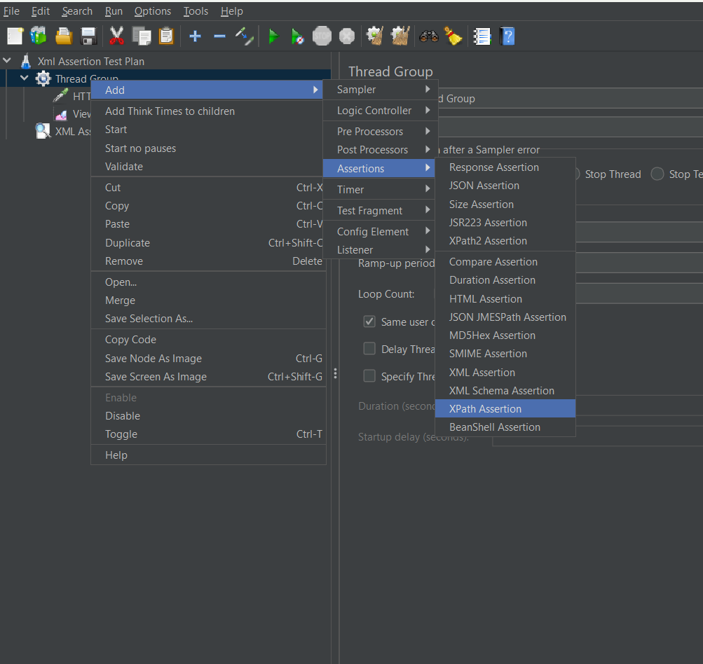

In xpath Assertion ,write the xpath ,it will validate it is present in xpath or not 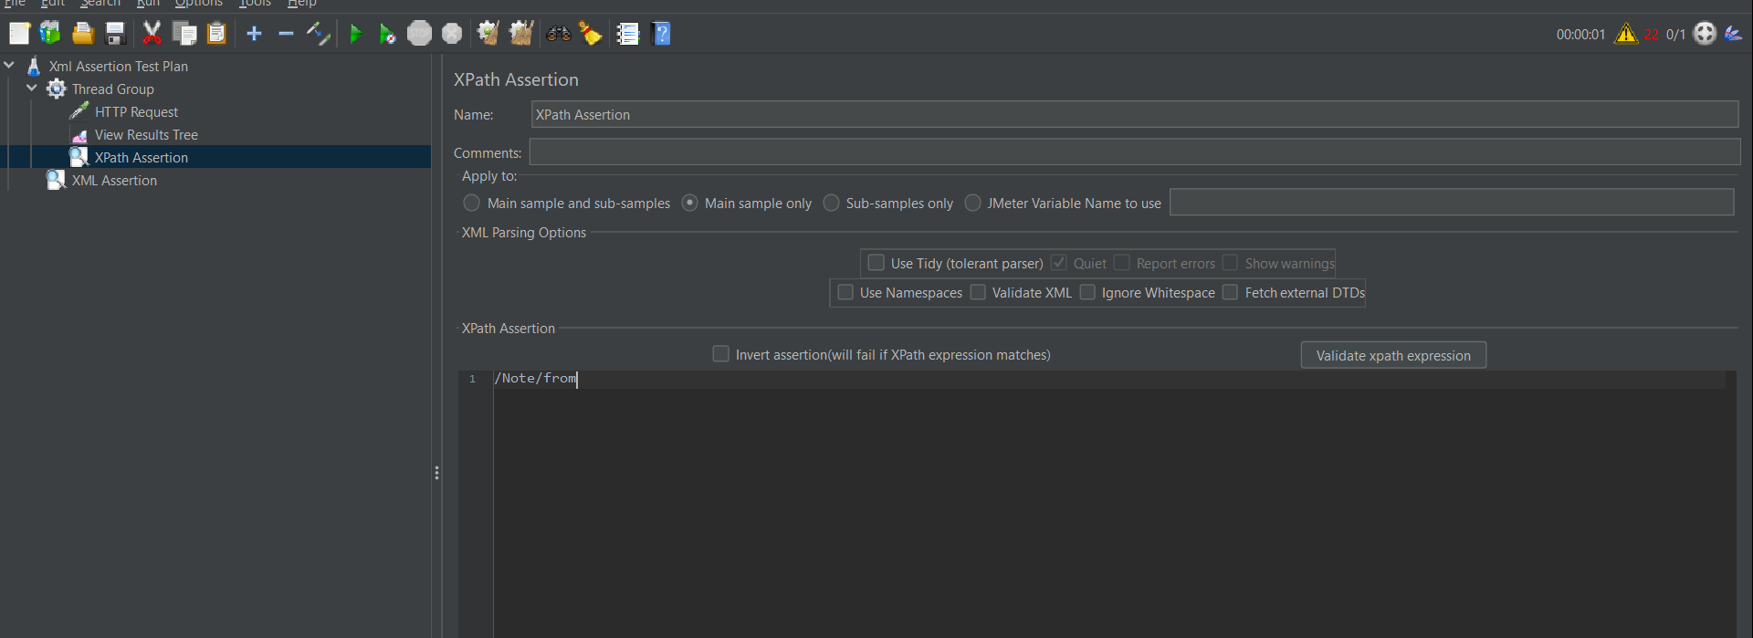

Run the test plan

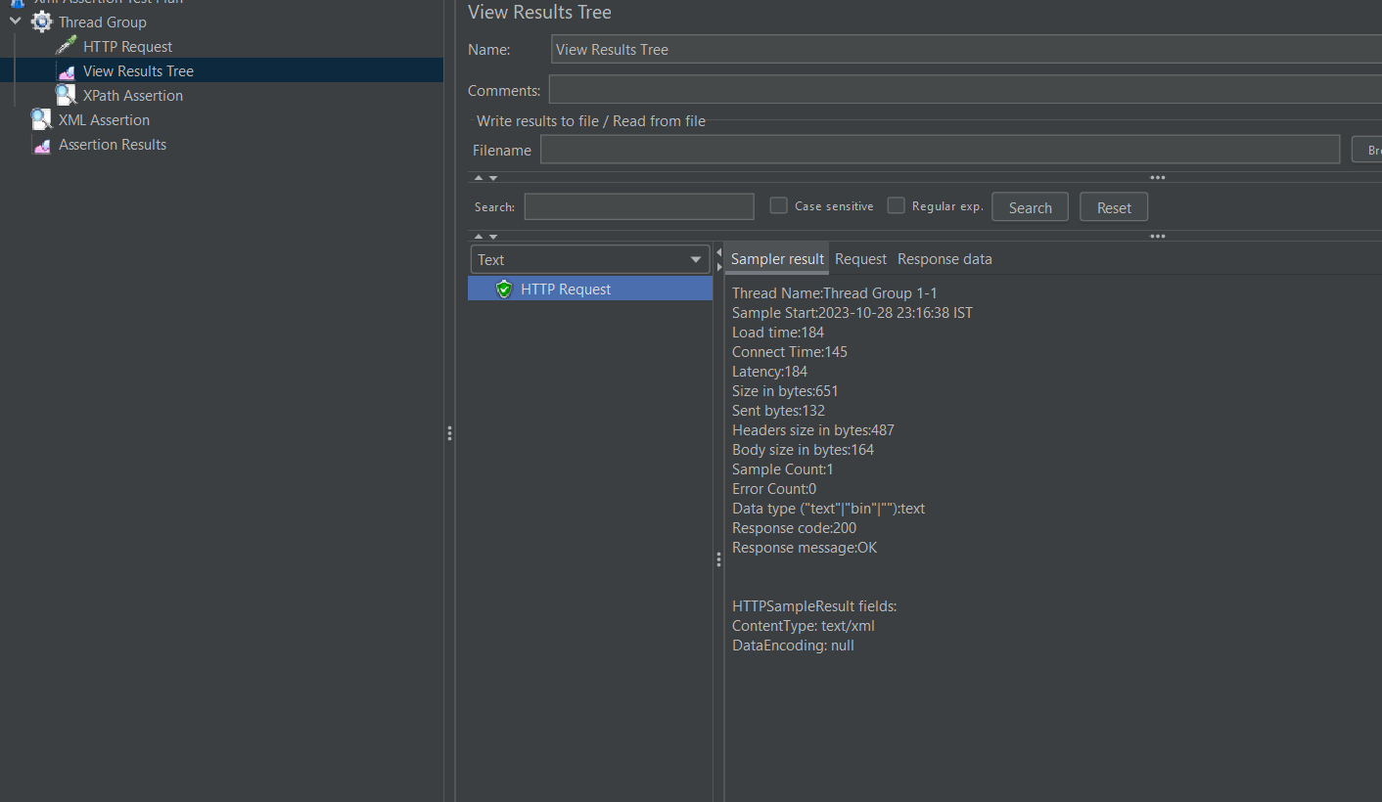

Comparison Assertion

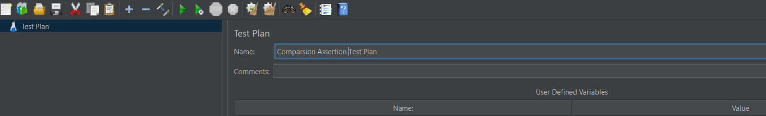

We are adding two Http request and compare them

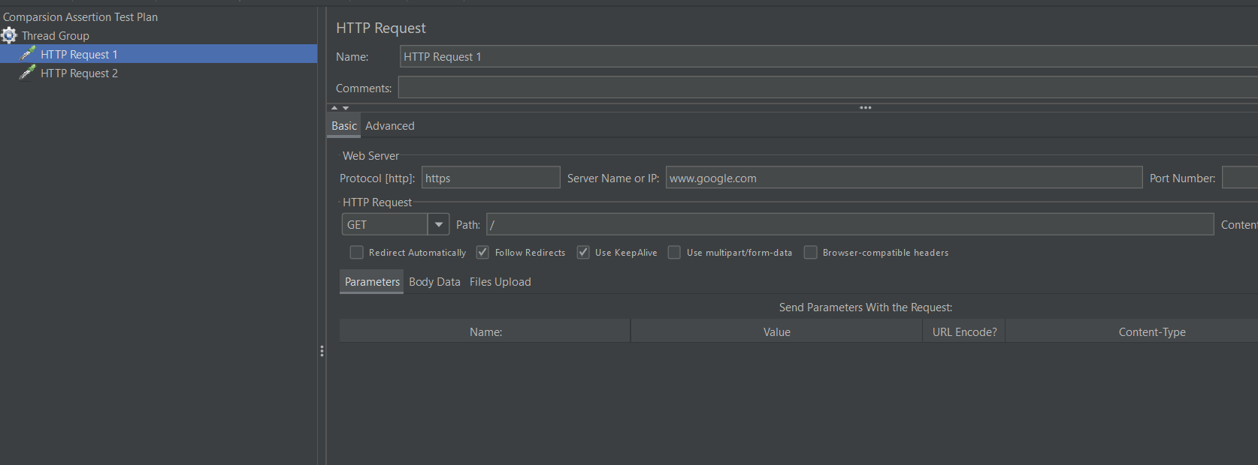

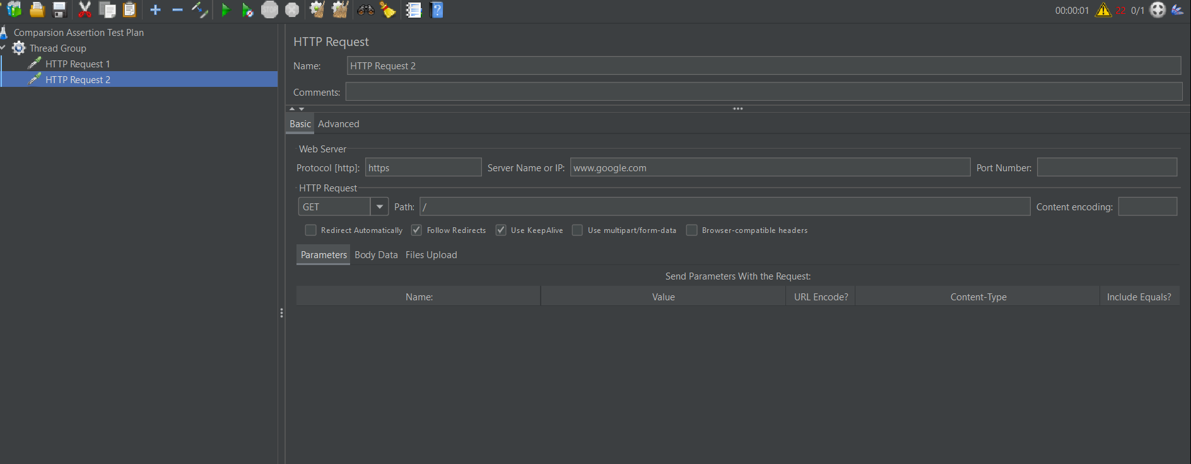

Comparison assertion is added to thread group to compare the both http request1 and http request 2 respectively

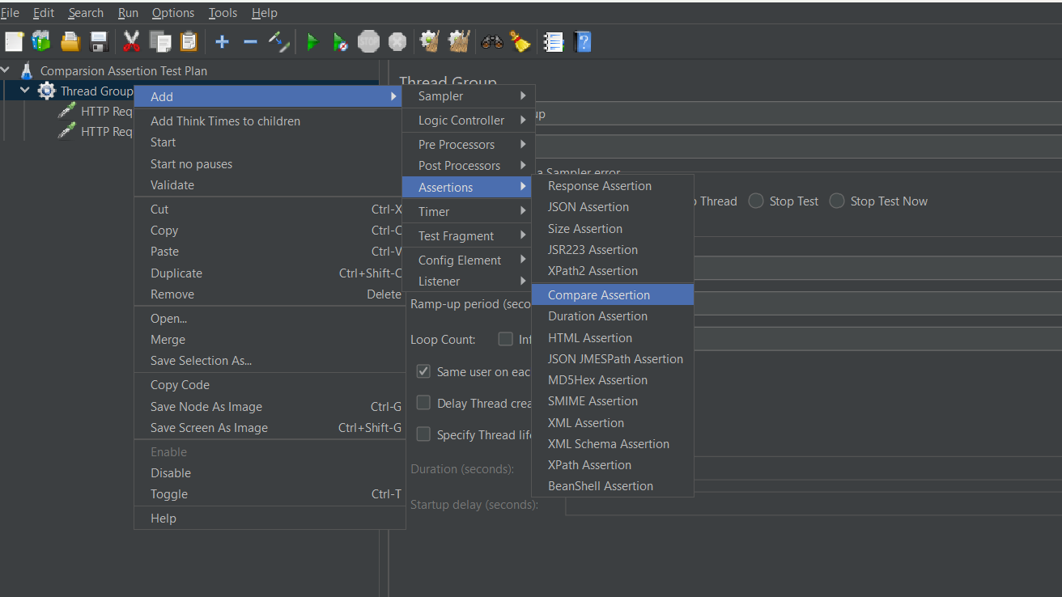

Running the test plan and viewing the result in view result tree.

